**App Bug Report**

**App Name: [ParkQwik | Parking | FASTag |RTO]**

1. **Introduction**

The purpose of this document is to provide a detailed report of bugs found in the [App Name] during testing. This report is intended for use in the selection process for [Company Name].

1. **Methodology**

* **Testing Tools**: Manual testing was conducted.
* **Testing Process**: The app was tested for various functionalities, and any discrepancies were noted. Steps to reproduce the bugs were documented, and the expected versus actual results were compared.

1. **Summary of Findings**

A total of 9 bugs were identified:

1. Unnecessary Song Playing on App Launch (Major, High Priority)

2. Buttons Redirecting to the Same Page (Major, High Priority)

3. Incomplete Display of City Names (Minor, Medium Priority)

4. Missing Confirmation Sound and OTP Issue (Critical, High Priority)

5. Confusing Hamburger Symbol (Minor, Low Priority)

6. Non-compliance Bugs (Major, Medium Priority)

7. Exposure of Personal Data (Critical, High Priority)

8. Default Map Image Issue (Major, Medium Priority)

9. Non-functional Icons (Major, Medium Priority)

1. **Detailed Bug Reports**
2. Bug #1: Unnecessary Song Playing on App Launch

* ID: BUG001
* Severity: Major
* Priority: High
* Status: Open
* Description: When the app is opened, a song begins to play. This behavior is not intended, and the song should not be played upon launching the app.
* Steps to Reproduce:

1. Open the ParkQwik | Parking | FASTag |RTO on the device.

* Expected Result: The app should launch without playing any song.
* Actual Result: A song starts playing as soon as the app is opened.
* Screenshots/Video:



* Additional Notes: This issue may be related to an unintended media playback command in the app's initialization code.

1. Bug #2: Buttons Redirecting to the Same Page

* ID: BUG002
* Severity: Major
* Priority: High
* Status: Open
* Description: Clicking any button in the app redirects to the same page instead of the respective pages.
* Steps to Reproduce:**

1. Open the app.

2. Click any button.

* Expected Result: Each button should redirect to its respective page.
* Actual Result: All buttons redirect to the same page.
* Screenshots/Video:

Main Page :

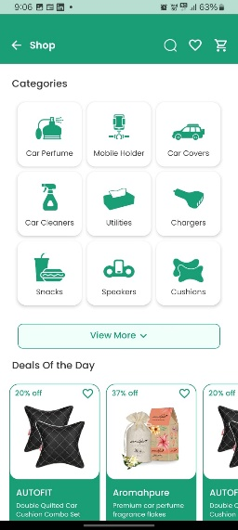

If we select the category it is directing to the same page for all categories:

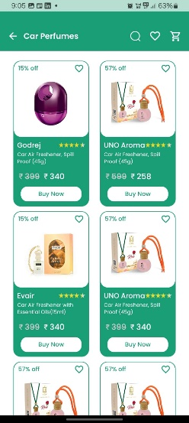

* Additional Notes: This could be due to incorrect routing or link assignments in the app.

1. Bug #3: Incomplete Display of City Names

* ID: BUG003
* Severity: Minor
* Priority: Medium
* Status: Open
* Description: The app displays only abbreviated city names and does not show all places in Tamil Nadu.
* Steps to Reproduce:

1. Open the app.

2. Navigate to the city list section.

* Expected Result: All city names in Tamil Nadu should be displayed in full.
* Actual Result: Only abbreviated names are displayed, and not all places are listed.
* Screenshots/Video:

It is shoeing the places only in Chennai :

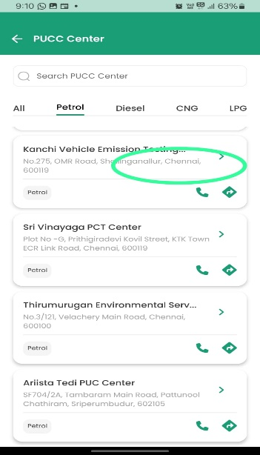

* Additional Notes: This may require an update to the city database or display logic.

1. Bug #4: Missing Confirmation Sound and OTP Issue

* ID: BUG004
* Severity: Critical
* Priority: High
* Status: Open
* Description: The confirmation sound after payment is missing, and has to give OTP confirmation before the payments.
* Steps to Reproduce:

1. Make a payment in the app.

2. Wait for the confirmation sound.

3. Enter the OTP.

* Expected Result: A confirmation sound should play after payment, and the OTP should be accepted.
* Actual Result: No confirmation sound plays, and the OTP is not accepted, returning to the previous page.
* Screenshots/Video:



* Additional Notes: This issue impacts user confidence in the payment process and needs urgent attention.

1. Bug #5: Confusing Hamburger Symbol

* ID: BUG005
* Severity: Minor
* Priority: Low
* Status: Open
* Description: The hamburger symbol in the profile image is confusing, resembling either a profile or a menu symbol.
* -Steps to Reproduce:

1. Open the profile section of the app.

* Expected Result: The symbol should clearly represent the profile.
* Actual Result: The symbol is ambiguous and confusing.
* Screenshots/Video:

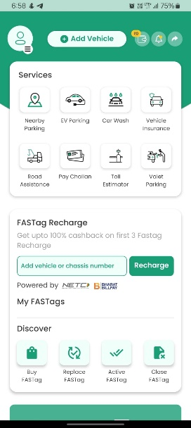

* Additional Notes: Consider redesigning the symbol for better clarity.

1. Bug #6: Exposure of Personal Data

* ID: BUG007
* Severity: Critical
* Priority: High
* Status: Open
* Description: Searching by registration number reveals the user's personal data.
* Steps to Reproduce:

1. Search by registration number in the app.

* Expected Result: Only limited, non-sensitive information should be displayed.
* Actual Result: Personal data is exposed.
* Screenshots/Video:

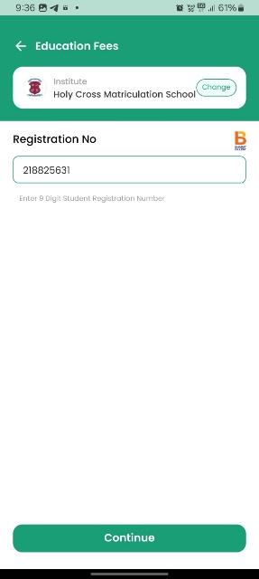 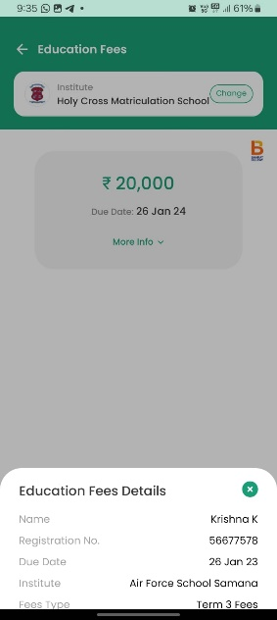

* Additional Notes: This is a significant privacy concern and must be addressed immediately.

1. Bug #8: Default Map Image Issue

* ID: BUG008
* Severity: Major
* Priority: Medium
* Status: Open
* Description: The map image shown is a default fixed image and does not reflect the currently searched places.
* Steps to Reproduce:

1. Search for a location in the app.

* Expected Result: The map should display the currently searched place.
* Actual Result: A default fixed image is shown.
* Screenshots/Video:

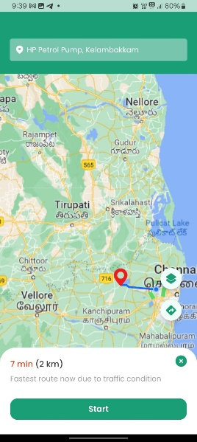

* Additional Notes: This affects the usability of the map feature.

1. Bug #9: Non-functional Icons

* ID: BUG009
* Severity: Major
* Priority: Medium
* Status: Open
* Description: Various icons in the app are not working properly.
* Steps to Reproduce:

1. Attempt to use different icons in the app.

* Expected Result: Icons should perform their intended functions.
* Actual Result: Icons do not work as expected.
* Screenshots/Video:

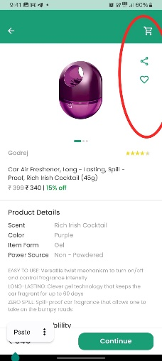 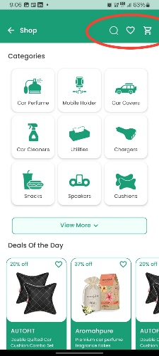

* Additional Notes: Review and correct the icon functionality.

1. Bug #10: Default Static Web Page on when we try to change State.

* ID: BUG010
* Severity: Major
* Priority: High
* Status: Open
* Description: Changing the state in the app results in a default static web page rather than the specific state page.
* Steps to Reproduce:

1. Change the state input in the app.

* Expected Result: The app should display the specific state page.
* Actual Result: The app displays a default static web page.
* Screenshots/Video:

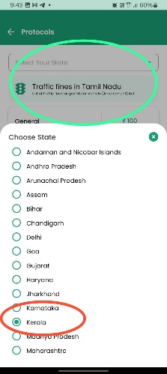

* Additional Notes: This affects state-specific information access.

1. Bug #11: Incorrect Payment Details

* ID: BUG011
* Severity: Critical
* Priority: High
* Status: Open
* Description: Payment pages show incorrect details, with constant values instead of dynamic values from the frontend.
* Steps to Reproduce:

1. Proceed to the payment section.

2. Note the displayed payment details.

* Expected Result: Payment details should be accurate and dynamic.
* Actual Result: Payment details are static and incorrect.
* Screenshots/Video:

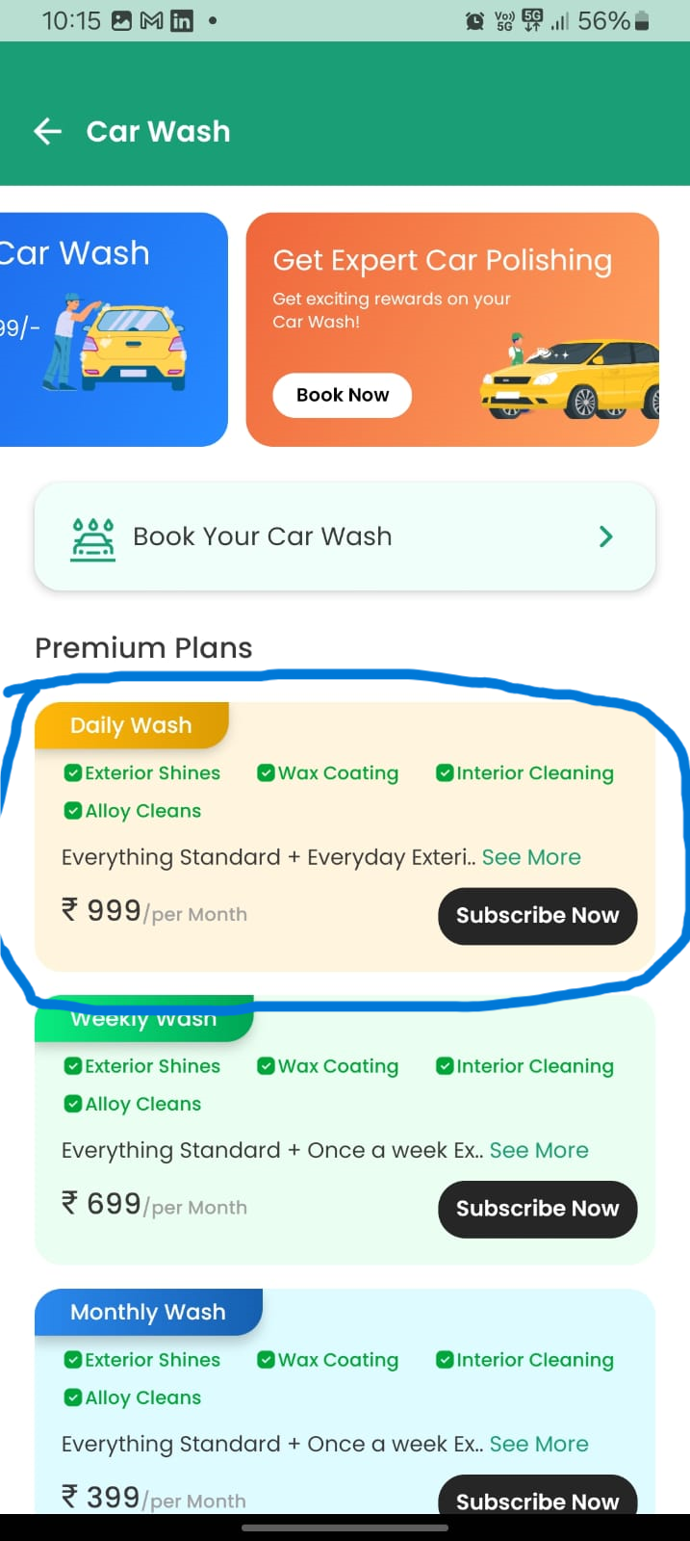 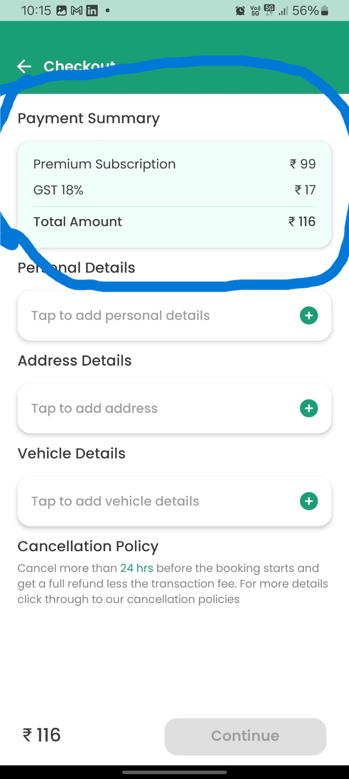

* Additional Notes: This affects payment accuracy and user trust.

1. Bug #12: Form Submission Error

* ID: BUG012
* Severity: Critical
* Priority: High
* status: Open
* Description: Submitting a form results in a white screen, and the form is not submitted.
* Steps to Reproduce:

1. Fill out a form in the app.

2. Submit the form.

* Expected Result: The form should be submitted successfully.
* Actual Result: The app displays a white screen.
* Screenshots/Video: [Attach any relevant screenshots or video if available]
* Additional Notes: This prevents form submissions and affects usability.

1. Bug #13: App Not Responding

* ID: BUG013
* Severity: Critical
* Priority: High
* Status: Open
* Description: The app sometimes does not respond, with backend issues affecting request handling.
* Steps to Reproduce:

1. Open the app and perform various actions.

* Expected Result: The app should respond to all user inputs.
* Actual Result: The app does not respond sometimes.
* Screenshots/Video:



* Additional Notes: This affects app reliability and user experience.

1. Bug #14: Irrelevant Content Related to Electricity and Water Bills

* ID: BUG014
* Severity: Minor
* Priority: Medium
* Status: Open
* Description: The app, related to cars and petroleum, contains content about electricity and water bills, which is not relevant.
* Steps to Reproduce:

1. Navigate to the pages with irrelevant content.

* Expected Result: The app should only have relevant content.
* Actual Result: Irrelevant content is displayed.
* Screenshots/Video:

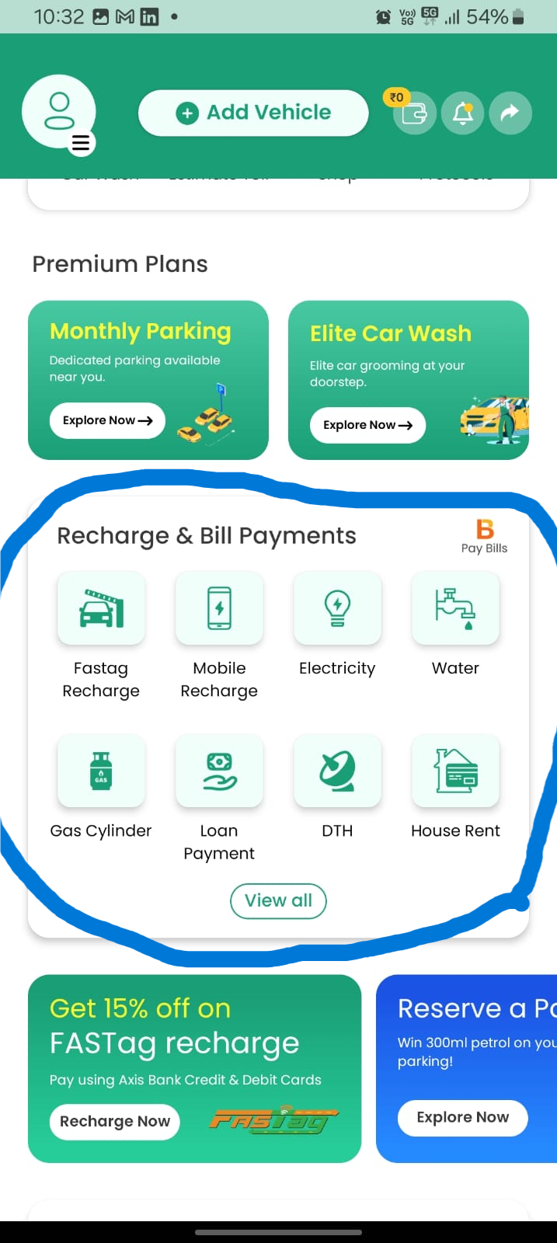

* Additional Notes: This affects content relevance and user perception.

**5. Conclusion**

The identified bugs impact various aspects of the app, including functionality, usability, and data privacy. Addressing these issues is crucial to ensure a smooth and secure user experience.